Additional files
Table S1. The difference of CNV copy number variation between tumor and normal groups
Gene | Normal CNV | Normal Wild | Tumor CNV | Tumor Wild | P-value
KIAA1429 | 0 | 389 | 195 | 184 | 1.06E-59
ALKBH5 | 0 | 389 | 119 | 260 | 9.03E-33
ZC3H13 | 1 | 388 | 113 | 266 | 3.42E-30
WTAP | 0 | 389 | 99 | 280 | 1.10E-26
FTO | 0 | 389 | 87 | 292 | 3.37E-23
METTL14 | 0 | 389 | 83 | 296 | 4.06E-22
YTHDF2 | 0 | 389 | 75 | 304 | 7.88E-20
YTHDC1 | 0 | 389 | 73 | 306 | 2.80E-19
YTHDC2 | 0 | 389 | 62 | 317 | 2.66E-16
YTHDF1 | 0 | 389 | 58 | 321 | 3.07E-15
RBM15 | 0 | 389 | 50 | 329 | 3.79E-13
METTL3 | 0 | 389 | 24 | 355 | 1.33E-06
HNRNPC | 2 | 387 | 28 | 351 | 2.25E-06
Table S2. Clinico-pathological features of patients included in this study.

 | TCGA dataset |  | ICGC dataset
 | Number | Percentage | Number | Percentage
Total | 350 | 100.00% | 260 | 100.00%
Age | 16-85 |  | 31-89
≤65 | 227 | 64.9% | 98 | 37.7%
>65 | 123 | 35.1% | 162 | 62.3%
Gender Female | 111 | 31.7% | 68 | 26.2%
Male | 239 | 68.3% | 192 | 73.8%
WHO Stage I | 174 | 49.7% | 40 | 15.4%
II | 85 | 24.3% | 117 | 45.0%
III | 86 | 24.6% | 80 | 30.8%
IV | 5 | 1.4% | 23 | 8.8%
Pathological Grade
G1 | 46 | 13.1% | - | -
G2 | 171 | 48.9% | - | -
G3 | 120 | 34.3% | - | -
G4 | 13 | 3.7% | - | -

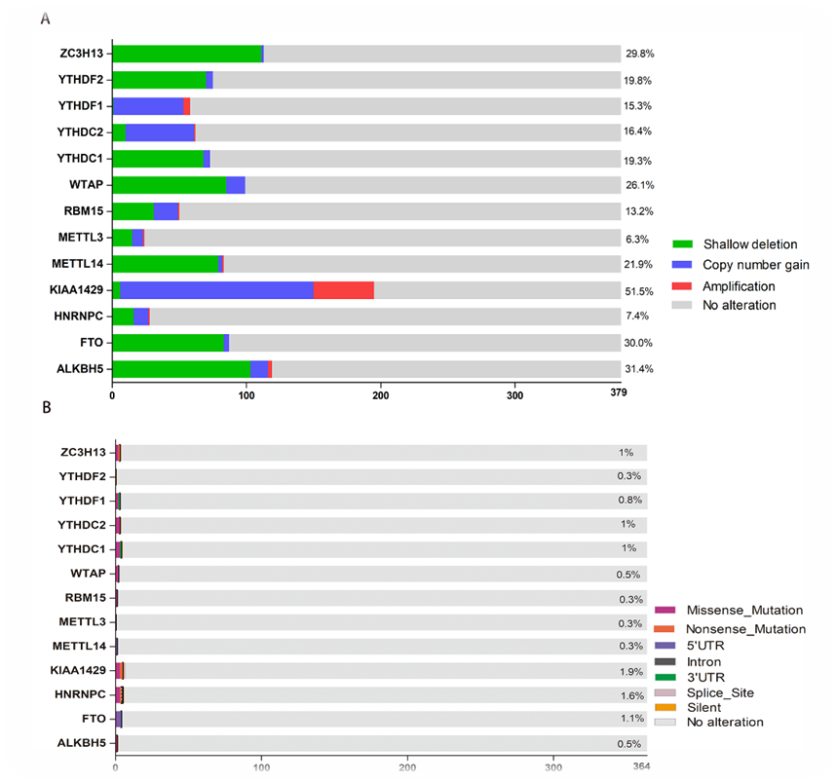
Figure S1. CNV copy number variation and SNP mutations of m6A RNA methylation modulators in HCC. (A) CNV copy number variation of the 13 genes in HCC tissues. Dioploid means normal; Shallow deletion means deletion of one copy number; Copy number gain means get a copy number; Amplification means get two or more copies. (B) SNP mutations of the 13 genes in HCC tissues. The vertical coordinate represents each gene, and the horizontal coordinate represents the number and type of SNP mutations of each gene in 364 tumor samples.

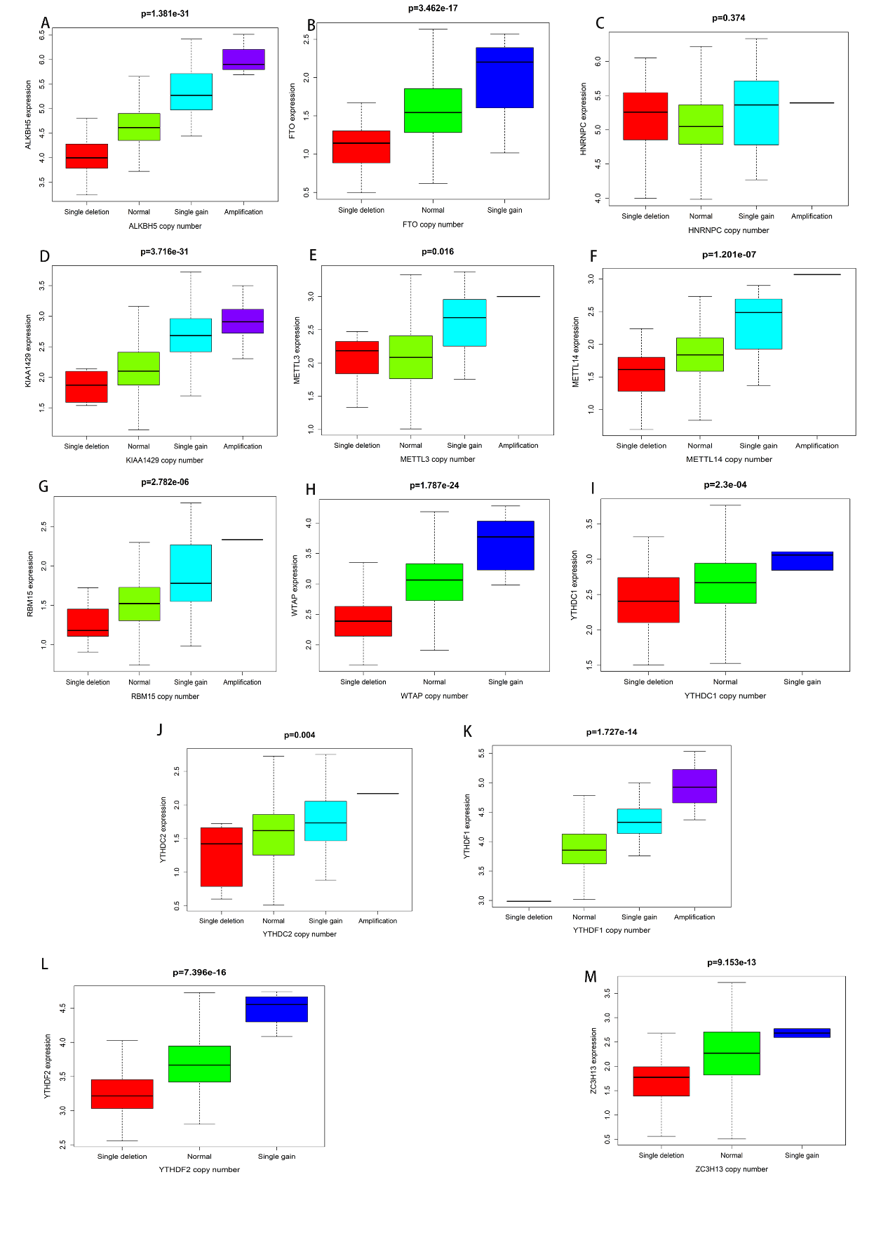
Figure S2.The relationship between mRNA expression of the 13 genes and copy number. (A-M) Kruskal-Wallis test was used for the differences among the groups, Single deletion means deletion of one copy number; Single gain means get a copy number; Amplification means get two or more copies.

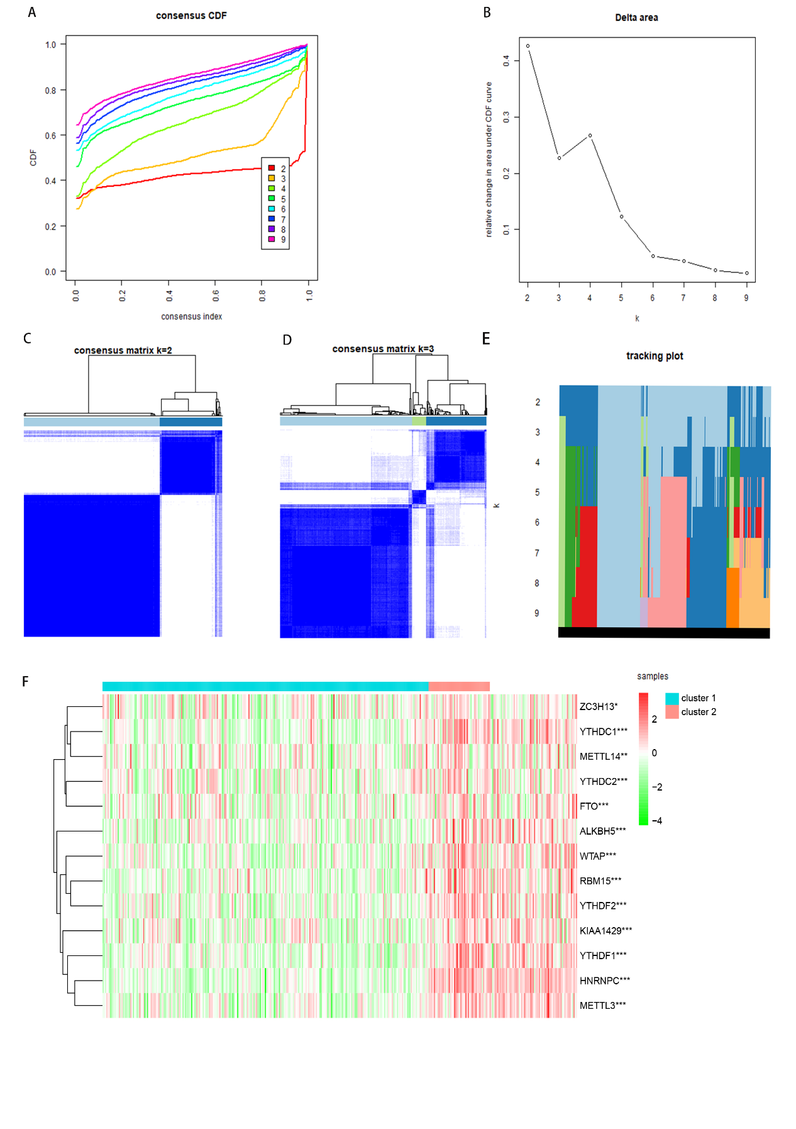
Figure S3. Consensus clustering of m6A RNA methylation modulators identified two clusters of hepatocellular carcinoma and gene differential expression between two clusters. (A)Consensus clustering cumulative distribution function (CDF) for k = 2 to 9. (B) Relative change in area under CDF curve for k = 2 to 9. (C-D) Consensus clustering matrix for k = 2(C) and k = 3(D). (E) The tracking plot for k=2 to k=9. (F) Heatmap of expression of m6A RNA methylation modulators of the two clusters, gene differential expression was tested by Wilcox test, * P < 0.05 and *** P < 0.001.

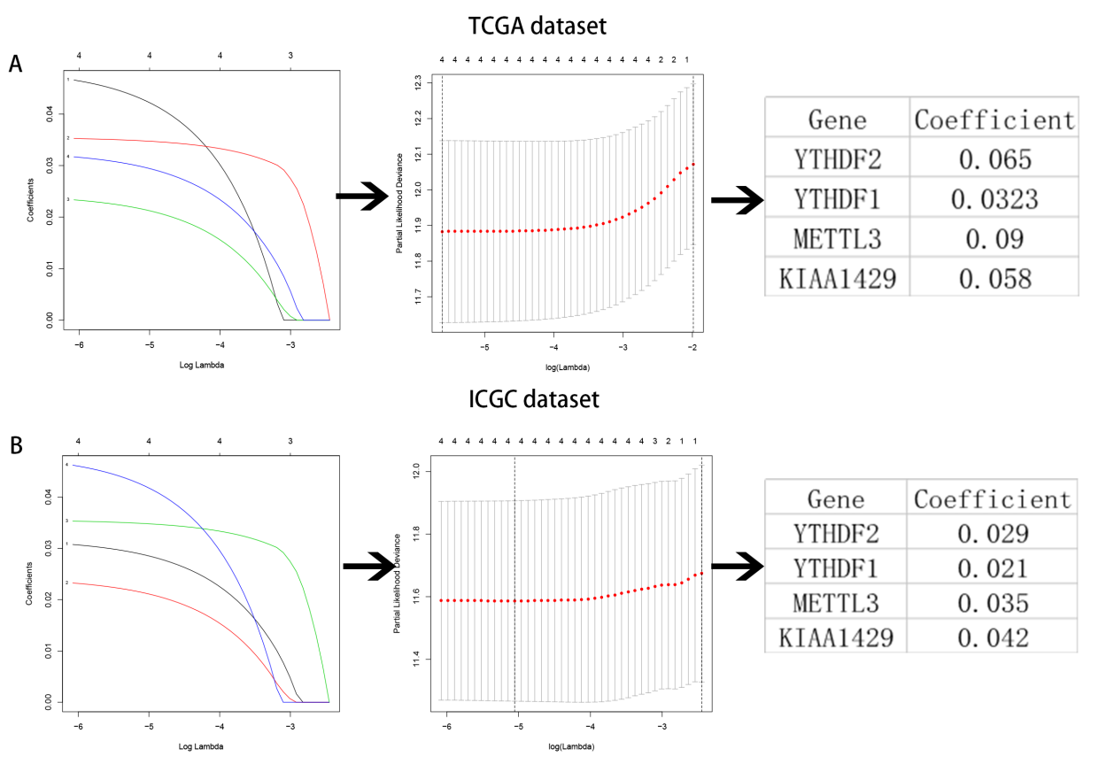
Figure S4. Risk signature with four common m6A RNA methylation modulators. (A-B) The process of building the signature containing four m6A RNA methylation modulators in two datasets. The hazard ratios (HR), 95% confidence intervals (CI) calculated by univariate Cox regression and the coefficients calculated by multivariate Cox regression using LASSO are shown.

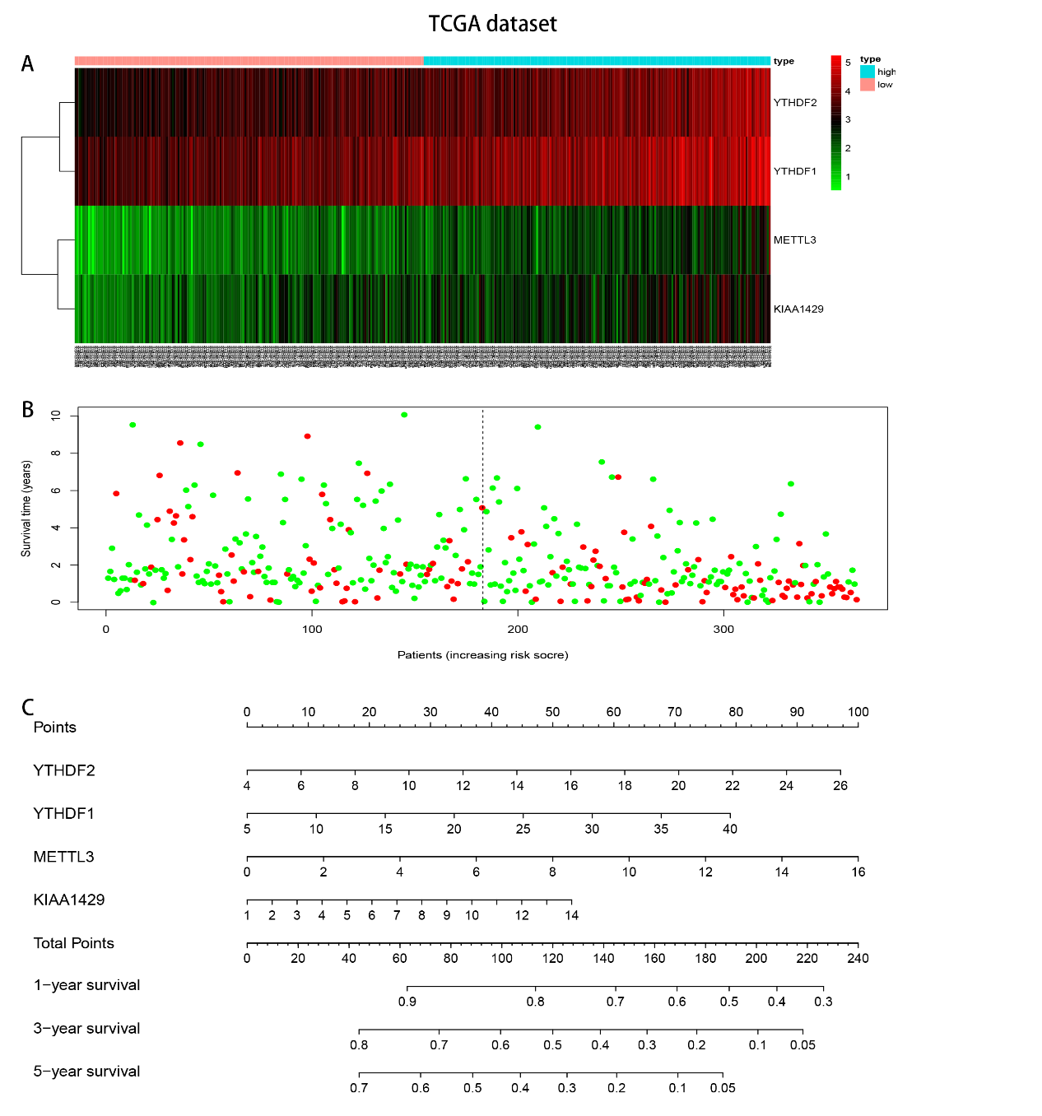Figure S5. Lasso risk regression model risk diagram in TCGA dataset. (A) Heatmap of the expression levels of the four selected m6A RNA methylation modulators in high- and low-risk patients. (B) Survival status map, the green dots on behalf of survival state, the red dots on behalf of death state. (C）Nomograms based on the risk score and clinicopathological factors to predict 1-, 3-, and 5-year survival rates.

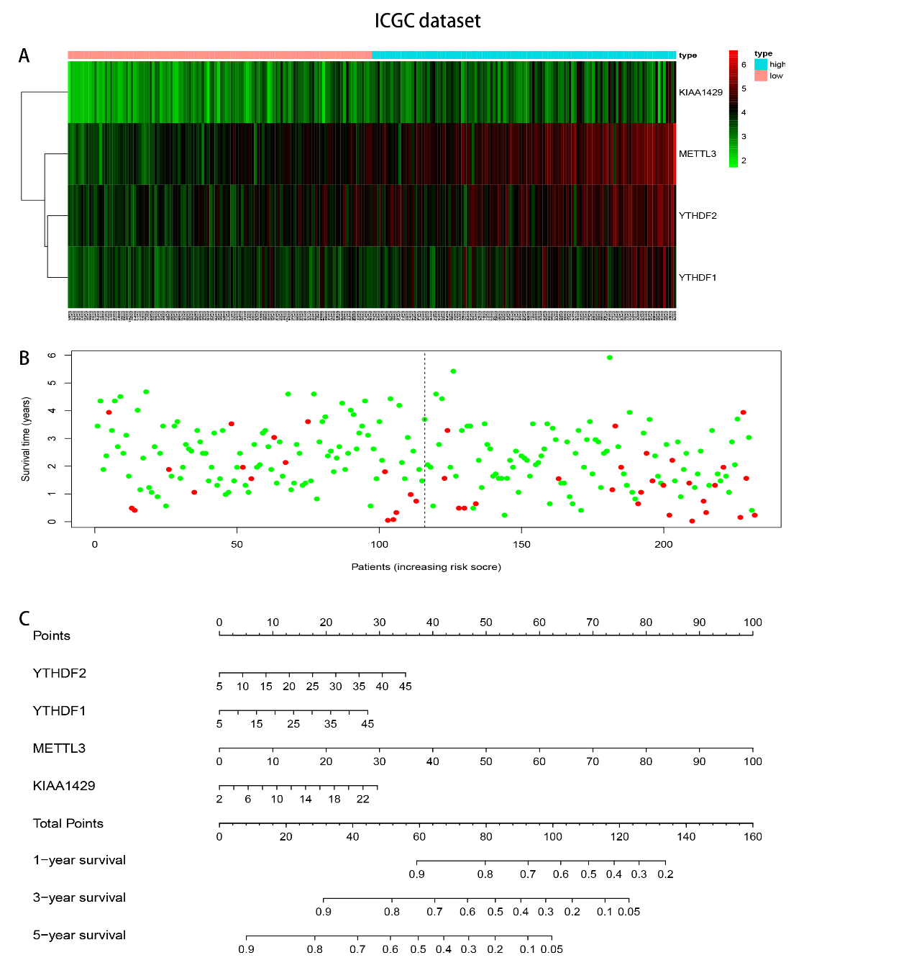
Figure S6. Lasso risk regression model risk diagram in ICGC dataset. (A) Heatmap of the expression levels of the four selected m6A RNA methylation modulators in high- and low-risk patients. (B) Survival status map, the green dots on behalf of survival state, the red dots on behalf of death state. (C）Nomograms based on the risk score and clinicopathological factors to predict 1-, 3-, and 5-year survival rates.

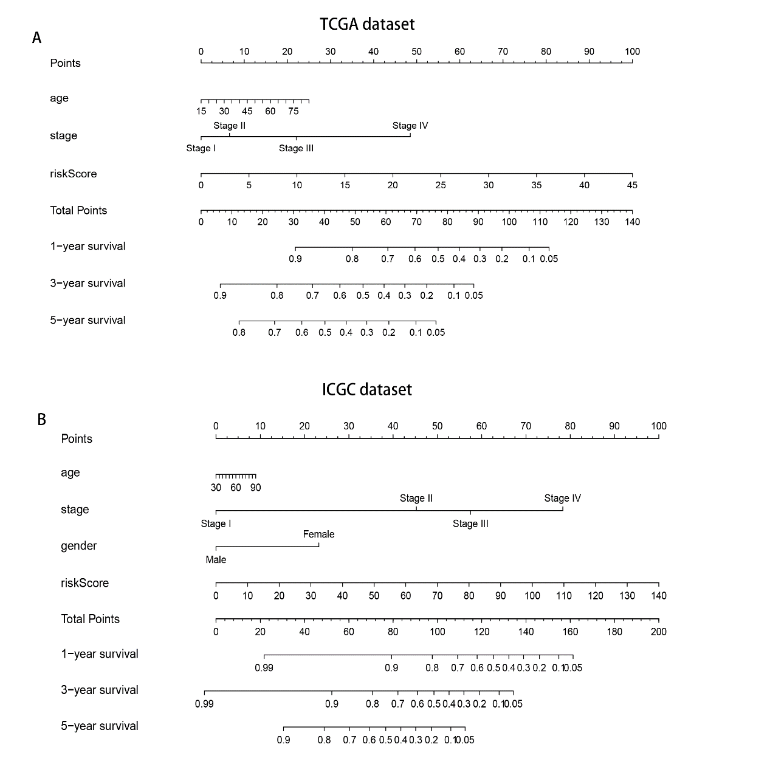
Figure S7. Nomograms combining risk values with clinicopathological factors to predict survival. (A) A comprehensive nomogram composed of age and stage combined with risk values, was used to predict 1-year, 3-year and 5-year survival rates in the TCGA database. (B)A comprehensive nomogram composed of age, stage and gender combined with risk values was used to predict the 1-year, 3-year and 5-year survival rate In the ICGC database.

